**MORNING STAR SCHOOL**

**ACADEMIC SESSION 2024-25**

**HOLIDAY HOMEWORK**

**GENERAL INSTRUCTIONS**

⭐The assignment should be done as per the instructions given.

⭐It should be neatly labelled with your name, class and section mentioned clearly.

⭐The last date of submission of holiday assignment is 5thJuly 2024.

⭐Students are requested to do a lot of reading of books related to their stream & newspapers.

⭐ Prepare yourself for the Periodic Test-I which is going to be held in the month of July.

**Holiday homework is intended to make students independent and enhance their skills and capabilities. Holiday homework helps to keep students on track and keep their brains ticking.**

**Subject:-ENGLISH CLASS-IV**

1. Practice one page handwriting daily.
2. Learn all the work done in your notebook.
3. Read the English E-newspaper daily and identify the difficult words, find their meaning from the dictionary. (at least 5 words daily)
4. Write 10 sentences on your own using helping verbs (eg. is, am, are, was, were, will, shall, have, has etc.) on an A4 size sheet.
5. Collect information on any two of the following personalities.

* Deepa Malik- Athlete.
* Mother Teresa- Social worker.
* Saina Nehwal- Badminton Player.
* Medha Patkar- Social Activist.

*Paste pictures, write about their achievements on a chart paper.

***WORKSHEET-1***

**Question 1. Sort these nouns in their respective types:-**

Taj Mahal, City, Apple, Narendra, Fruit, Team, Agra, Swarm, Car, Office, Colony, Zoo, Gwalior, Jury, Audience, Table, Coffee, Glass, Room, Bathroom, Rekha , Country, Galaxy, Mountain, Kerela, Plantation.

|  |  |  |
| --- | --- | --- |
| **Common nouns** | **Proper nouns** | **Collective nouns** |
|  |  |  |
|  |  |  |
|  |  |  |
|  |  |  |
|  |  |  |
|  |  |  |
|  |  |  |

**Question 2. Rewrite these sentences by changing masculine noun to feminine and vice-versa.**

1. Richa has three brothers.
2. The farmer bought some hens.
3. His grandmother is a teacher.
4. The queen sits on the throne.

**Question 3. Complete the sentences by using the adjectives given in the bracket.**

(lazy, black, sufficient, kind, costly, green)

* I have________ money to spend today.
* She is a _______ lady.
* The _______ cat is sleeping on the couch.
* He is a ______ boy.
* Cashmere is a _______ wool.

**Question 4. Fill in the blanks with the articles. (a, an, the)**

1. She is ___ experienced politician.
2. Yesterday I saw __ film about aliens.
3. Narendra Modi is ___ current prime minister of India.
4. I will reach home after ___ hour.
5. ___ famous Rajkot chutney is one of ___ kind of chutnies.
6. He went to __ party.
7. ___ party is for Christmas.
8. Republic of India is ___ country.

**Subject:-HINDI CLASS-IV**

प्रश्नन. 1 .. कोई दस पत्तियाँ अपनी कॉपी में चिपकाइये तथा उनके नाम भी लिखिये।

प्रश्नन. 2 .. वर्ण माला का सुंदर चार्ट बनाइये।

प्रश्नन. 3 .. कोई एक कविता सुंदर शब्दों में लिखिये।

प्रश्नन. 4 .. सातदिनोंकेनामहिंदीमेंलिखिये।

प्रश्नन.5 ..' हिंदीसुलेख ' किताब को पेज न. 20 तक भरिये।

प्रश्नन. 6 .. हिंदी कॉपी में बीस पेज सुंदर शब्दों में सुलेख लिखिये।

**कार्यपत्रक-1**

**प्रश्नन. 1 निम्न शब्दों के विलोम शब्द लिखिये**

क-जान

ख-संभव

ग-सफल

घ-ऊपर

**प्रश्नन. 2 निम्न शब्दों को जोड़कर लिखिये**

क- मंद - सीहवा

ख- गुमसुमफूल

ग- नीलाआसमान

घ- सुहानीसुबह

**प्रश्नन. 3 शब्दों के स्त्री लिंग शब्द लिखिये।**

क-बालक

ख-देवता

ग-चूहा

घ-चाचा

**Subject:-EVS CLASS-IV**

1. Do you have a pet? If not, then imagine you have one, describe it in 5 sentences.
2. Learn everything done in your EVS notebook and textbook.
3. Help your mother in household activities like folding clothes, arranging groceries and other chores.

(ASK YOUR PARENTS TO WRITE THEIR FEEDBACK ABOUT YOUR WORK IN YOUR NOTEBOOK)

**WORKSHEET-1**

Health and hygiene

(Choose the correct and fill in the blanks from A-E)

1. Sound sleep is important for the health of our:-
2. Ear
3. Brain
4. Hair
5. We must visit a _______________ for the regular checkup of our teeth.
6. Physician
7. Surgeon
8. Dentist
9. Which of the following food item contains calcium:-
10. Honey
11. Milk
12. Potato
13. You should brush your teeth:-
14. All the time
15. Twice a day
16. Never
17. Which of the following is an energy giving food:-
18. Minerals
19. Vitamins
20. Carbohydrates

**ACTIVITY**

5.Tick the suitable option from the given oviparous and viviparous animals. (Activity attached)

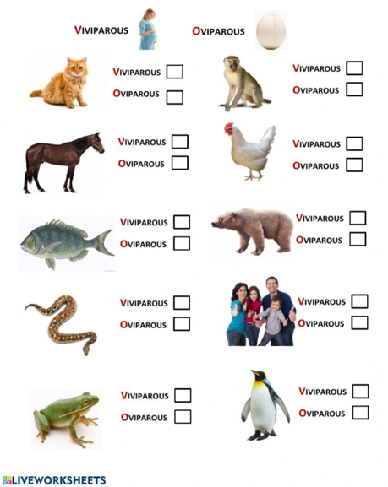

**Subject:-MATHEMATICS CLASS-IV**

1. Using a chart paper paste pictures of any 5 great Indian Mathematicians with their names on it.

2. Draw an angular clock on A4 sheet showing 5 different times of the day.

3. Learn tables from 2 to 20 and write tables 5 times on an A4 sheet.

ACTIVITY

Colour the rangoli using different colours and try to find different geometrical shapes in the given worksheet.

**WORKSHEET-1**

I) MULTIPLE CHOICE QUESTIONS:

1. In short form, 60000+2000+100+7 is written as:

(a) 62117 (b) 60217 (c)62107 (d) 62701

1. The smallest 6-digit number is:

(a)100000 (b)10000 (c)999999 (d)99999

1. Write in expanded form:
2. 21680
3. 53670
4. 32415
5. 64361
6. Make the largest and the smallest numbers using the following digits:
7. 8,3,7,9,5
8. 5,0,3,9,4
9. Write the number names in the Indian number system:
10. 58934
11. 38963
12. 46405
13. 16983
14. The Roman number for 26 is:

(a)XXXVI (b) XXVI (c) VXXI (d)IVXX

**Subject:-SPOKEN ENGLISH CLASS-IV**

* Watch the movie ‘Alice through the looking glass’ and write about your experience.
* Learn common sentences used in daily life in English and write them along with hindi translation.

**Subject:-COMPUTER CLASS-IV**

1. Write Memory Classification Chart and draw Types of Memory Chart in scrapbook.

**Subject:-ART & CRAFT CLASS-IV**

1. Decorate a bottle with Acrylic colours ( Draw flowers, Mandala, Cartoon face.)

**\*ACTIVITY RECOMMENDED DURING VACATION\***

* Meditate and do simple yoga exercises .
* Water plants and feed the birds.
* Join your grandparents and parents for their morning walk.
* Help your mother in the kitchen .
* Don’t watch too much of television .
* keep your environment in surrounding clean .
* Plant trees and conserve your natural resources.
* Build and improve your vocabulary through crosswords, jumble words etc.
* Solve riddles and puzzles.
* Read story books and visit places.
* Improve your reading and writing skills by reading and writing.

**Note:**

* **Summer breaks are from 5th May to 23 June 2024. The school will**

**reopens on 24th June 2024**

***Have a great***

***Summer Vacation***